Information: Facebook has a feature called Town Hall. It allows you to follow and connect with your state and federal representatives.

First, click the ‘See more’ area under Explore to the left of your Facebook homepage (desktop):

cid:image001.png@01D2CB0E.A06B1A40cid:image002.png@01D2CB0E.A06B1A40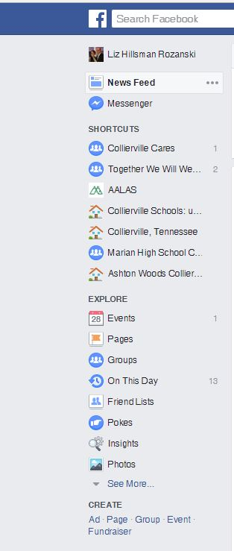

Then scroll down to the bottom and click on Town Hall:

cid:image004.png@01D2CB0E.A06B1A40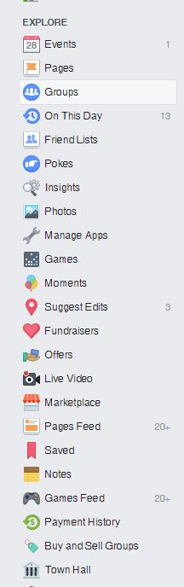

You can also type Town Hall in your search area and the following will come up (smartphone):

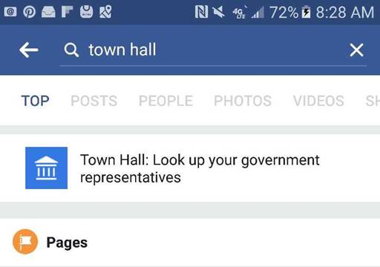

Once you click on the app, you will see options to follow and/or contact to various reps from your area as seen below:

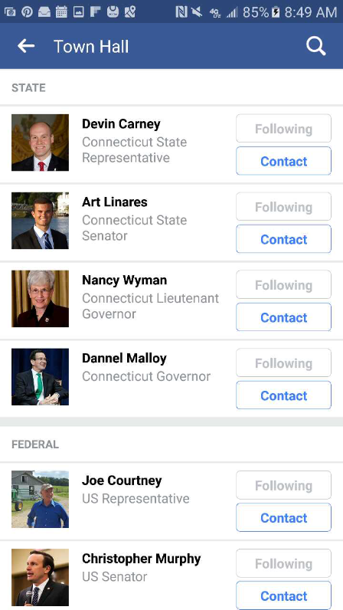

Also be aware that “Follow” is not equivalent to “Like”.  If you Follow someone it allows you to see all their public posts….it is not endorsing them in any way.